HTML QUICK-STYLER
Naan Mudhalvan Project Report Submitted to Manonmaniam Sundaranar University in The Partial fulfilment of the Requirement for the award of the Degree of Bachelor of Science in Information Technology.
Submitted By
Team ID: SWTID-2026-8962
Team Leader: FATHIMA FARHANA J – 23082241808412012
Team Member: HALEEMA RAIHANATH MUHSINA I R – 23082241808412016
Team Member: SAMIRA JESMIN M – 23082241808412039
Team Member: SEYED ALI FATHIMA S – 23082241808412040



DEPARTMENT OF INFORMATION TECHNOLOGY
WAVOO WAJEEHA WOMEN’S COLLEGE OF ARTS & SCIENCE
KAYALPATNAM – 628 204
APRIL – 2026

CERTIFICATE

WAVOO WAJEEHA WOMEN’S COLLEGE OF ARTS AND SCIENCE
KAYALPATNAM – 628 204
CERTIFICATE
This is to certify that project entitled as
“HTML QUICK STYLER”
Is a Bonafide work done by
1. FATHIMA FARHANA J – 23082241808412012
2. HALEEMA RAIHANATH MUHSINA I R – 23082241808412016
3. SAMIRA JESMIN M – 23082241808412039
4. SEYED ALI FATHIMA S – 23082241808412040

In partial fulfilment of the requirement for B.Sc. Degree Course in Information Technology (2025-2026) of the Manonmaniam Sundaranar University for Naan Mudhalvan Course (Agentic AI Application Developer) is done.

Signature of the Staff Incharge

Signature of the H.O.D EXTERNAL EXAMINERS

1.

2.

DECLARATION

DECLARATION

This project is submitted for the Naan Mudhalvan Course Agentic AI Application Developer
Subject code __________ and the external examination is conducted on _____________.

Signature of the Candidates

1. FATHIMA FARHANA J

2.HALEEMA RAIHANATH MUHSINA I R

3. SAMIRA JESMIN M

4. SEYED ALI FATHIMA S

DATE:
PLACE: Kayalpatnam

CONTENT

TABLE OF CONTENT
S.NO | TOPIC | PAGE NO
1 | PROJECT DESCRIPTION | 1
2 | SCENARIOS | 3
3 | ARCHITECTURE OVERVIEW | 6
4 | PROJECT WORKFLOW | 9
5 | PROJECT STRUCTURE | 13
6 | IMPLEMENTATION PHASE | 15
7 | SCREENSHOTS | 27
8 | CONCLUSION | 31

PROJECT DESCRIPTION

1. PROJECT DESCRIPTION

HTML Quick-Styler is an advanced web page generation platform that uses IBM’s Granite 3.3 2B Instruct model to create complete HTML and CSS web pages with professional styling and responsive layouts. The system helps simplify and speed up web development by providing AI-driven HTML generation, automatic section identification, modern CSS design, color palette selection, and production-ready code.
By utilizing the powerful language capabilities of Granite 3.3 2B, the platform interprets user inputs such as the page title, required sections, and preferred color themes. It then generates a well-structured semantic HTML layout, applies modern CSS styling with animations, builds responsive page designs, and offers multiple color palette choices. The platform also ensures a smooth user experience through Gradio’s intuitive interface, while maintaining high-quality design standards with intelligent templates and AI-assisted content suggestions.
Overall, HTML Quick-Styler makes web development easier and more efficient by combining a modern Gradio interface, powerful AI analysis, and a rich set of features that generate customized HTML pages based on design trends, accessibility guidelines, and responsive design principles.

SCENARIOS

2. SCENARIOS

Scenario 1: Portfolio Website Generation
A freelance designer wants to build a professional portfolio website in a fast and efficient way. The system begins by identifying the project needs and understanding the designer’s preferred style and design choices. Based on this analysis, it automatically creates a complete website layout.
The generated website includes an attractive hero section with a welcoming message and a clear call-to-action that immediately captures the visitor’s attention. It also creates a responsive portfolio gallery arranged in a neat grid format so that projects can be displayed effectively on different devices. An About section is added to introduce the designer’s professional background and experience in a clear and engaging way.
To enhance trust and credibility, the system also adds a testimonials section that displays feedback from clients. In addition, a contact form with proper input validation is included to allow visitors to communicate easily while reducing possible errors. Finally, a professional footer containing social media links and important information is generated to give the website a complete and polished appearance.
Scenario 2: SaaS Landing Page
A startup company requires an effective landing page to introduce and promote their new product. The system begins by generating an engaging hero banner that clearly presents the product’s main value and important message to capture visitors’ attention.
Next, it creates a features section that highlights the product’s capabilities using attractive icons and short, clear descriptions, making the advantages easy for users to understand. The system also designs a pricing comparison table that presents different plan options in a simple and organized format, helping customers compare and choose the most suitable plan.
To increase reliability and customer confidence, a testimonials section is included to display positive feedback and user experiences. Additionally, the page contains strategically placed call-to-action buttons that encourage visitors to sign up or make a purchase, improving the overall conversion rate of the landing page
Scenario 3: Corporate Website
A company needs a professional corporate website that contains multiple well-organized sections. The system generates a clean and modern layout, beginning with a sticky navigation header that displays the company’s branding and allows users to move smoothly between different sections of the website.
It then creates a company overview section that clearly presents the organization’s mission, vision, and core values. A services section is also developed in a grid format to display the company’s offerings in a structured and visually appealing way.
To build trust and add a personal element, the website includes a team members section featuring photos and brief profiles of the staff. In addition, a contact section is provided with company details and an inquiry form to enable easy communication with visitors.
Finally, the website is completed with a professional footer that includes privacy policies and important links, ensuring the overall design meets corporate website standards.
Scenario 4: Custom Color Palette Exploration
A designer wishes to explore multiple color schemes to identify the most suitable visual identity for their project. The system generates eight well-designed color palettes, including themes such as modern, vibrant, ocean, forest, sunset, luxury, creative, and minimal.
Each palette includes clearly specified hex color codes for different elements, making it easy to apply them during development. The platform also offers a real-time preview feature, enabling the designer to instantly see how each color palette influences the overall appearance of the design.
The system ensures consistent color usage across all page elements to maintain visual balance and harmony. In addition, it provides dark theme–optimized background options, supporting modern design trends and improving user comfort, especially in low-light viewing conditions.

ARCHITECTURE OVERVIEW

3. ARCHITECTURE OVERVIEW

HTML Quick-Styler is designed as a modular system that integrates a Python backend with the IBM Granite 3.3 2B Instruct model to enable intelligent HTML generation. The platform focuses on delivering a smooth user experience, high-quality design output, and production-ready code through Gradio’s interactive interface and advanced template generation methods.

Core Technologies
• Python 3.x: The primary programming language used to implement the application logic.
• IBM Granite 3.3 2B Instruct: AI model used to generate structured and intelligent web content.
• Gradio: A framework used to build the interactive web interface for user interaction.
• HTML5 / CSS3: Modern web technologies used for generating structured web pages and styling.
• JavaScript: Used to add client-side interactivity and dynamic animations.
• Google Colab: Cloud-based environment used for development and execution.
• Responsive Design: Implements a mobile-first design approach using media queries.

Pre-requisites

Software Requirements
• Python 3.8 or higher: Can be downloaded from python.org.
• Google Account: Required to access and run projects on Google Colab.
• Gradio Library: Installed using pip (pip install gradio).
• Web Browser: Any modern browser such as Chrome, Firefox, Safari, or Edge.
• Internet Connection: Necessary for accessing Google Colab and the AI model.

Knowledge Prerequisites
• Python Fundamentals: Basic knowledge of functions, classes, dictionaries, and string handling.
• HTML and CSS: Understanding of HTML page structure and CSS styling techniques.
• Gradio Framework: Basic familiarity with creating and managing interface components.
• Web Design Concepts: Knowledge of color theory and responsive design principles.
• Google Colab: Experience with using the notebook-based development environment.

Hardware Requirements
• Processor: Intel i3 or an equivalent processor (main processing is handled in the cloud via Colab).
• RAM: At least 4GB of local memory (Google Colab can provide additional GPU/TPU resources).
• Storage: Minimum of 1GB available space for saving generated files.
• Display: Screen resolution of at least 1280 × 720 for proper interface viewing.

PROJECT WORKFLOW

4. PROJECT WORKFLOW

Phase 1: Environment Setup & Model Configuration
Prepare the Google Colab environment and configure the Granite model.

Activity 1.1: Setting Up the Google Colab Environment
• Create a new notebook in Google Colab.
• Enable GPU runtime to improve performance.
• Install all required Python libraries and packages.
• Check and confirm that the environment is properly configured.

Activity 1.2: Configuring the IBM Granite Model
• Access the model from the Hugging Face repository.
• Load the Granite 3.3 2B Instruct model into the environment.
• Test the model to ensure it performs inference correctly.
• Adjust and set the text generation parameters.

Activity 1.3: Installing and Setting Up Gradio
• Install the Gradio library using pip.
• Create a simple test interface using Gradio.
• Configure sharing and access options.
• Confirm that the interface loads and displays correctly.

Phase 2: Core Application Development
Develop the main HTML generation system and template structure.

Activity 2.1: Creating the Color Palette Generator
• Develop a ColorPaletteGenerator class.
• Define eight different color palette themes.
• Implement logic for selecting and applying palettes.
• Add a method to validate the selected color values.

Activity 2.2: Implementing the HTML Page Builder
• Develop the HTMLPageBuilder class.
• Design an algorithm to automatically detect required sections.
• Implement methods for generating HTML templates.
• Create a generator for SEO-friendly meta tags.

Activity 2.3: Developing the CSS Generation Engine
• Build a complete CSS generation module.
• Implement rules to support responsive web design.
• Add visual effects such as animations and transitions.
• Create mobile-first media queries for different screen sizes.

Activity 2.4: Creating Section Templates
• Design a template for the hero section.
• Develop a features grid template.
• Implement a portfolio gallery layout template.
• Add a contact form template.
• Create templates for pricing plans and testimonials.

Phase 3: Gradio Interface Development
Develop an interactive user interface with multiple tabs.

Activity 3.1: Interactive HTML Generation and Preview Interface
Phase 3 focuses on building a complete interface that allows users to generate, customize, and preview HTML pages easily. The system provides a structured and user-friendly workflow where users can design web page layouts, visualize the results instantly, and understand the generated structure through an intuitive multi-section interface.

Phase 4: Google Colab Deployment
Integrate all system components and carry out complete testing.

Activity 4.1: End-to-End Integration
• Connect all user interface components together.
• Test the data flow across different tabs.
• Verify the HTML generation pipeline.
• Check and validate error handling mechanisms.

Phase 5: Deployment and Documentation
Deploy the application and prepare detailed documentation.

Activity 5.1: Functionality Testing
• Configure the sharing settings in Gradio.
• Enable a public access link for the application.
• Test access from external users or devices.
• Record and document the deployment process.
TECHNICAL STRUCTURE
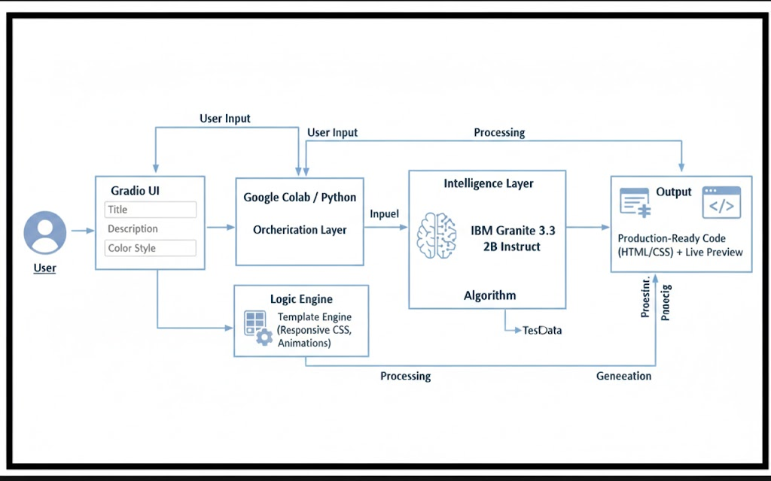

PROJECT STRUCTURE

5.PROJECT STRUCTURE

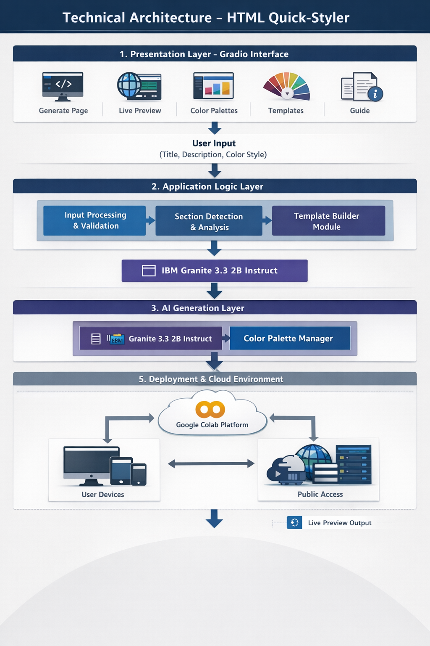

IMPLEMENTATION PHASE

6. IMPLEMENTATION PHASE

Activity 1.1: Install Dependencies & Setup Environment
!pip install -q gradio
import gradio as gr
import json
import re
from datetime import datetime
from typing import Tuple, Dict, List
import random

Activity 2.1: Color Palette Generator Implementation
class ColorPaletteGenerator:
"""Generate visually cohesive color palettes"""
@staticmethod
def generate_palette(style: str = "modern") -> Dict[str, str]:
"""Generate a cohesive color palette based on style"""
palettes = {
'modern': {
'primary': '#667eea',
'secondary': '#764ba2',
'accent': '#f093fb',
'background': '#0f172a',
'surface': '#1e293b',
'text_primary': '#f1f5f9',
'text_secondary': '#cbd5e1',
'border': '#334155'
},
'vibrant': {
'primary': '#ff6b6b',
'secondary': '#ff8e72',
'accent': '#f5576c',
'background': '#0f172a',
'surface': '#1e293b',
'text_primary': '#f1f5f9',
'text_secondary': '#cbd5e1',
'border': '#334155'
},
'ocean': {
'primary': '#0099cc',
'secondary': '#006699',
'accent': '#00ccff',
'background': '#0f172a',
'surface': '#1e293b',
'text_primary': '#f1f5f9',
'text_secondary': '#cbd5e1',
'border': '#334155'
},
'forest': {
'primary': '#27ae60',
'secondary': '#1e8449',
'accent': '#52be80',
'background': '#0f172a',
'surface': '#1e293b',
'text_primary': '#f1f5f9',
'text_secondary': '#cbd5e1',
'border': '#334155'
},
'sunset': {
'primary': '#ff8c42',
'secondary': '#ff6b35',
'accent': '#ffa751',
'background': '#0f172a',
'surface': '#1e293b',
'text_primary': '#f1f5f9',
'text_secondary': '#cbd5e1',
'border': '#334155'
},
'luxury': {
'primary': '#1a1a1a',
'secondary': '#333333',
'accent': '#FFD700',
'background': '#0f172a',
'surface': '#1e293b',
'text_primary': '#f1f5f9',
'text_secondary': '#cbd5e1',
'border': '#334155'
},
'creative': {
'primary': '#9b59b6',
'secondary': '#8e44ad',
'accent': '#e74c3c',
'background': '#0f172a',
'surface': '#1e293b',
'text_primary': '#f1f5f9',
'text_secondary': '#cbd5e1',
'border': '#334155'
},
'minimal': {
'primary': '#2c3e50',
'secondary': '#34495e',
'accent': '#3498db',
'background': '#0f172a',
'surface': '#1e293b',
'text_primary': '#f1f5f9',
'text_secondary': '#cbd5e1',
'border': '#334155'
}
}

Activity 2.2: HTML Page Builder Implementation
class HTMLPageBuilder:
"""Build styled HTML pages from descriptions"""
@staticmethod
def extract_sections(description: str) -> List[str]:
"""Extract sections from description"""
sections = []
section_keywords = {
'hero': ['hero', 'banner', 'landing'],
'features': ['features', 'services', 'benefits'],
'about': ['about', 'team', 'company'],
'portfolio': ['portfolio', 'gallery', 'work', 'projects'],
'testimonials': ['testimonial', 'reviews', 'feedback'],
'pricing': ['pricing', 'plans', 'cost'],
'contact': ['contact', 'form', 'reach'],
'footer': ['footer', 'bottom']
}
desc_lower = description.lower()
for section_type, keywords in section_keywords.items():
for keyword in keywords:
if keyword in desc_lower:
sections.append(section_type)
break
if not sections:
sections = ['hero', 'features', 'contact', 'footer']
return sections
@staticmethod
def generate_meta_tags(title: str, description: str) -> str:
"""Generate SEO meta tags"""
meta_tags = f''' <meta charset="UTF-8">
<meta name="viewport" content="width=device-width, initial-scale=1.0">
<title>{title}</title>
<meta name="description" content="{description[:160]}">
<meta name="theme-color" content="#0f172a">
<meta property="og:title" content="{title}">
<meta property="og:description" content="{description[:160]}">
<meta property="og:type" content="website">
<meta name="twitter:card" content="summary_large_image">
<meta name="author" content="HTML Quick-Styler">'''
return meta_tags
@staticmethod
def generate_section_html(section_type: str, palette: Dict) -> str:
"""Generate HTML for specific section"""
sections = {
'hero': f''' <section class="hero">
<div class="hero-content">
<h1>Welcome to Your Site</h1>
<p>Create amazing web experiences</p>
<button class="btn btn-primary">Get Started</button>
</div>
</section>''',
'features': f''' <section class="features">
<h2>Features</h2>
<div class="features-grid">
<div class="feature-card">
<h3>Fast</h3>
<p>Lightning-quick performance</p>
</div>
<div class="feature-card">
<h3>Secure</h3>
<p>Enterprise-grade security</p>
</div>
<div class="feature-card">
<h3>Scalable</h3>
<p>Grow without limits</p>
</div>
</div>
</section>''',
'about': f''' <section class="about">
<div class="about-content">
<h2>About Us</h2>
<p>We're passionate about creating beautiful, functional websites that help your business grow.</p>
</div>
</section>''',
'portfolio': f''' <section class="portfolio">
<h2>Our Work</h2>
<div class="portfolio-grid">
<div class="portfolio-item"></div>
<div class="portfolio-item"></div>
<div class="portfolio-item"></div>
</div>
</section>'''

Activity 2.3: CSS Generation Engine
@staticmethod
def generate_css(palette: Dict) -> str:
"""Generate comprehensive CSS"""
css = f''' <style>
* {{
margin: 0;
padding: 0;
box-sizing: border-box;
}}
:root {{
--primary: {palette['primary']};
--secondary: {palette['secondary']};
--accent: {palette['accent']};
--background: {palette['background']};
--surface: {palette['surface']};
--text-primary: {palette['text_primary']};
--text-secondary: {palette['text_secondary']};
--border: {palette['border']};
}}
body {{
font-family: 'Segoe UI', Tahoma, Geneva, Verdana, sans-serif;

Activity 3.1: Gradio Interface Development
background: linear-gradient(135deg, var(--background) 0%, var(--surface) 100%);
color: var(--text-primary);
line-height: 1.6;
min-height: 100vh;
}}
header {{
background: rgba(15, 23, 42, 0.95);
backdrop-filter: blur(10px);
padding: 1.5rem 2rem;
position: sticky;
top: 0;
z-index: 100;
border-bottom: 1px solid var(--border);
}}
header nav {{
display: flex;
justify-content: space-between;
align-items: center;
max-width: 1200px;
margin: 0 auto;
}}
header h1 {{
font-size: 1.8rem;
background: linear-gradient(135deg, var(--primary), var(--accent));
-webkit-background-clip: text;
-webkit-text-fill-color: transparent;
background-clip: text;
}}
header nav a {{
color: var(--text-secondary);
text-decoration: none;
margin: 0 1.5rem;
transition: color 0.3s ease;
}}
header nav a:hover {{
color: var(--primary);
}}
main {{
max-width: 1200px;
margin: 0 auto;
padding: 0 2rem;
}}
section {{
padding: 4rem 0;
animation: fadeIn 0.6s ease-in;
}}
@keyframes fadeIn {{
from {{
opacity: 0;
transform: translateY(20px);
}}
to {{
opacity: 1;
transform: translateY(0);
}}
}}
h1, h2, h3 {{
color: var(--text-primary);
margin-bottom: 1rem;
}}
h1 {{
font-size: 3rem;
font-weight: 700;
}}
h2 {{
font-size: 2rem;
margin-bottom: 2rem;
text-align: center;
}}
h3 {{
font-size: 1.3rem;
}
.hero {{
background: linear-gradient(135deg, var(--primary) 0%, var(--secondary) 100%);
color: white;
padding: 6rem 0;
text-align: center;
min-height: 500px;
display: flex;
align-items: center;
justify-content: center;
}}
.hero h1 {{
color: white;
font-size: 4rem;
margin-bottom: 1rem;
animation: slideDown 0.8s ease;
}}
.hero p {{
font-size: 1.5rem;
margin-bottom: 2rem;
opacity: 0.95;
animation: slideUp 0.8s ease;
}}
@keyframes slideDown {{
from {{
opacity: 0;
transform: translateY(-30px);
}}
to {{
opacity: 1;
transform: translateY(0);
}}
}}
@keyframes slideUp {{
from {{
opacity: 0;
transform: translateY(30px);
}}
to {{
opacity: 1;
transform: translateY(0);
}}
}}
.btn {{
padding: 0.8rem 2rem;
border: none;
border-radius: 8px;
font-size: 1rem;
cursor: pointer;
transition: all 0.3s ease;
font-weight: 600;
}}
.btn-primary {{
background: var(--primary);
color: white;
box-shadow: 0 4px 15px rgba(0,0,0,0.3);
}}
.btn-primary:hover {{
transform: translateY(-2px);
box-shadow: 0 6px 20px rgba(0,0,0,0.4);
background: var(--accent);
}}
.btn-secondary {{
background: var(--secondary);
color: white;
}}
.btn-secondary:hover {{
background: var(--primary);
}}
.features-grid {{
display: grid;
grid-template-columns: repeat(auto-fit, minmax(250px, 1fr));
gap: 2rem;
}}
.feature-card {{
background: rgba(30, 41, 59, 0.8);
padding: 2rem;
border-radius: 12px;
border: 1px solid var(--border);
transition: all 0.3s ease;
backdrop-filter: blur(10px);
}}
.feature-card:hover {{
transform: translateY(-8px);
border-color: var(--primary);
box-shadow: 0 20px 40px rgba(0,0,0,0.3);
}
.feature-card h3 {{
color: var(--primary);
margin-bottom: 0.5rem;
}}
.feature-card p {{
color: var(--text-secondary);
}}
.portfolio-grid {{
display: grid;
grid-template-columns: repeat(auto-fit, minmax(280px, 1fr));
gap: 2rem;
}}
.portfolio-item {{
aspect-ratio: 1;
background: linear-gradient(135deg, var(--primary), var(--secondary));
border-radius: 12px;
cursor: pointer;
transition: all 0.3s ease;
border: 1px solid var(--border);
}}
.portfolio-item:hover {{
transform: scale(1.05);
box-shadow: 0 20px 40px rgba(0,0,0,0.3);
}}
.about {{
text-align: center;
}}
.about-content {{
max-width: 800px;
margin: 0 auto;
}}
.about p {{
font-size: 1.1rem;
color: var(--text-secondary);
}}
.testimonials-grid {{
display: grid;
grid-template-columns: repeat(auto-fit, minmax(300px, 1fr));
gap: 2rem;
}}
.testimonial {{
background: rgba(30, 41, 59, 0.8);
padding: 2rem;
border-left: 4px solid var(--primary);
border-radius: 8px;
}}
.testimonial p {{
font-style: italic;
margin-bottom: 1rem;
color: var(--text-secondary);
}}
.testimonial span {{
font-weight: 600;
color: var(--primary);
}}
.pricing-grid {{
display: grid;
grid-template-columns: repeat(auto-fit, minmax(300px, 1fr));
gap: 2rem;
}}
.pricing-card {{
background: rgba(30, 41, 59, 0.8);
padding: 2rem;
border-radius: 12px;
border: 1px solid var(--border);
text-align: center;
transition: all 0.3s ease;
}}
.pricing-card.featured {{
border-color: var(--primary);
box-shadow: 0 20px 40px rgba(0,0,0,0.3);
transform: scale(1.05);
}}
.pricing-card .price {{
font-size: 2.5rem;
color: var(--primary);
margin: 1rem 0;
font-weight: 700;
}}
.pricing-card ul {{
list-style: none;
margin: 1.5rem 0;
text-align: left;
}}
.pricing-card li {{
padding: 0.5rem 0;
color: var(--text-secondary);
}}
.contact {{
max-width: 600px;
margin: 0 auto;
}}
.contact-form {{
display: flex;
flex-direction: column;
gap: 1.5rem;
}}
.contact-form input,
.contact-form textarea {{
padding: 1rem;
border: 1px solid var(--border);
border-radius: 8px;
background: rgba(30, 41, 59, 0.8);
color: var(--text-primary);
font-family: inherit;
font-size: 1rem;
}}
.contact-form input:focus,
.contact-form textarea:focus {{
outline: none;
border-color: var(--primary);
box-shadow: 0 0 0 3px rgba(0,0,0,0.3);
}}
.footer-content {{
max-width: 1200px;
margin: 0 auto;
padding: 0 2rem;
display: flex;
justify-content: space-between;
align-items: center;
flex-wrap: wrap;
gap: 2rem;
}}
.footer-links {{
display: flex;
gap: 2rem;
}}
.footer-links a {{
color: var(--text-secondary);
text-decoration: none;
transition: color 0.3s ease;
}}
.footer-links a:hover {{
color: var(--primary);
}}@media (max-width: 768px) {{
header nav {{
flex-direction: column;
gap: 1rem;
}}
header h1 {{
font-size: 1.4rem;
}}.hero h1 {{
font-size: 2rem;
}}
.hero p {{
font-size: 1.1rem;
}}
h2 {{
font-size: 1.5rem;
}}main {{
padding: 0 1rem;
}}
section {{
padding: 2rem 0;
}}.footer-content {{
flex-direction: column;
text-align: center;
}}
}}
</style>'''
return css

SCREENSHOTS

8. SCREENSHOTS

- Application Running in Google Colab

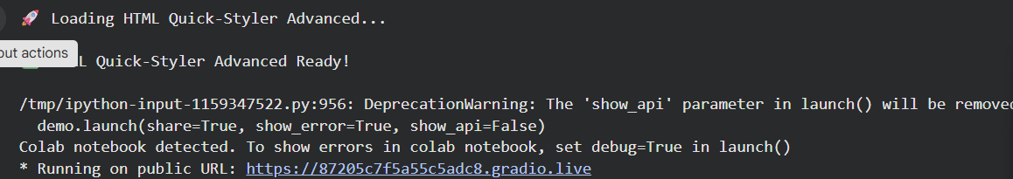

- Generated Gradio Public URL
Public URL: : https://87205c7f5a55c5adc8.gradio.live
This screenshot shows the public URL generated by Gradio which allows users to access the application through a web browser.
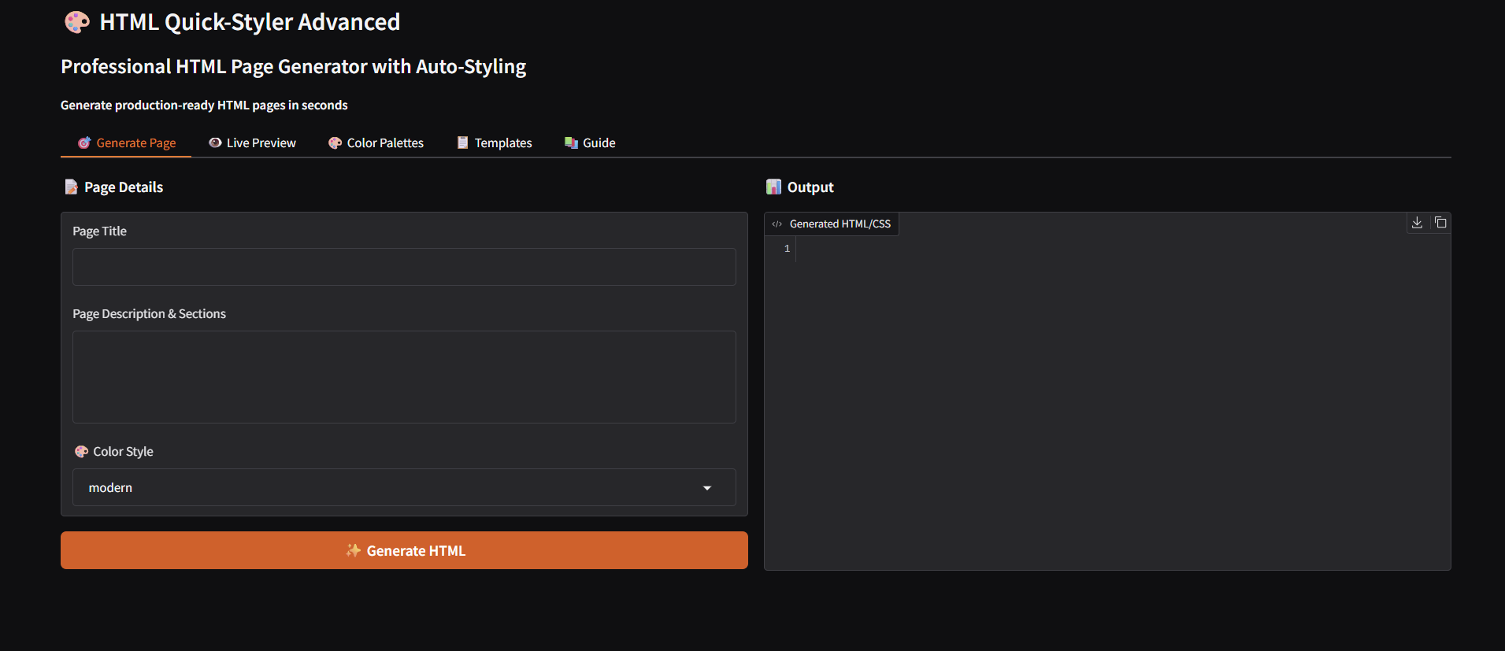

- Website Generation Input Interface

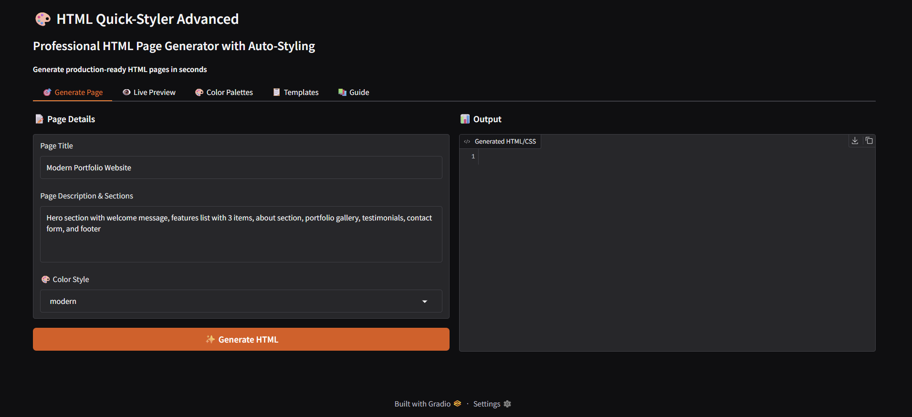

- Generated Website Output

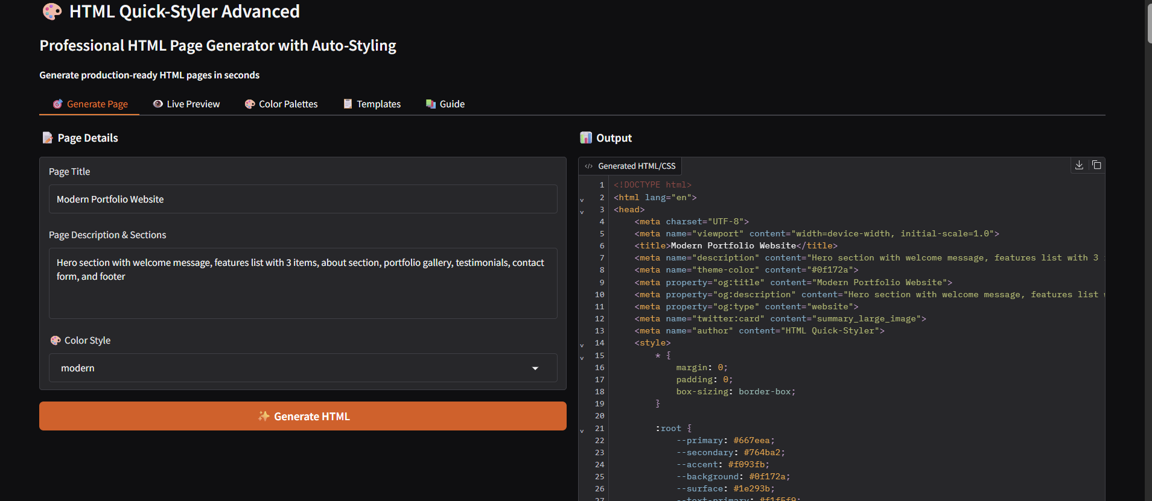

- Final Generated Website
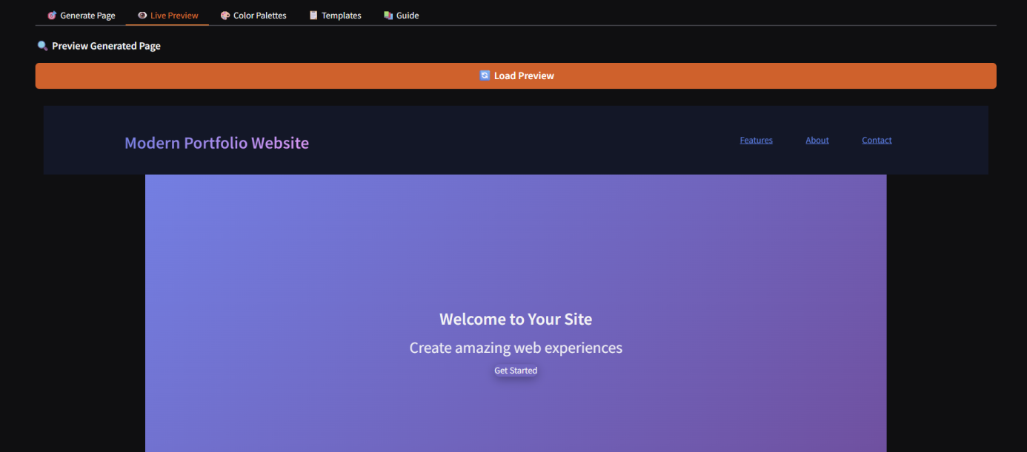

- Color Palette Selection
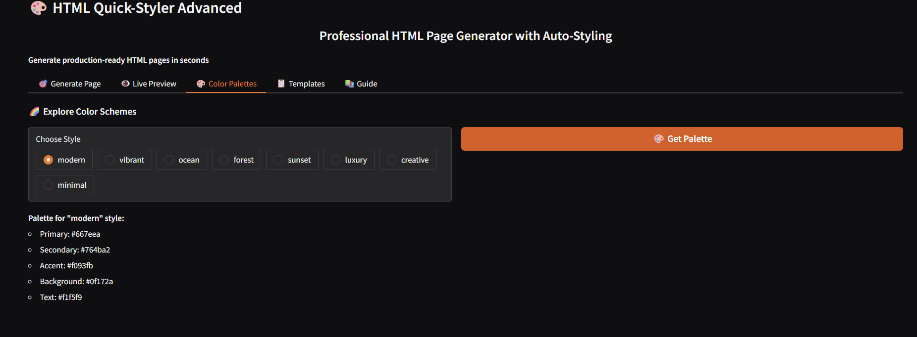

- Templates
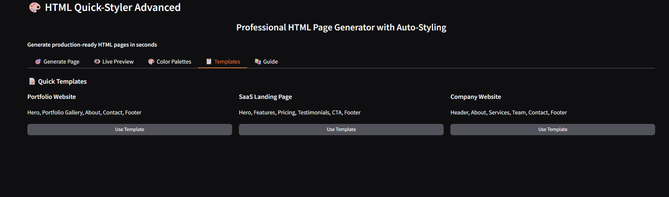

CONCLUSION

8. CONCLUSION

HTML Quick-Styler effectively functions as an intelligent web page generation assistant by combining user-friendly design templates with the capabilities of the IBM Granite 3.3 2B Instruct model. By utilizing Gradio’s interactive interface framework and the cloud-based environment of Google Colab, the platform enables fast, professional, and customizable HTML and CSS generation. This makes the system accessible not only to developers but also to designers and users with limited technical knowledge.
The platform highlights the potential of AI-supported web development, allowing users to create professional web pages quickly while maintaining high design quality, responsive layouts, and production-ready code. With features such as eight unique color palettes, automatic section recognition, and multiple template options, HTML Quick-Styler allows users to design attractive websites within minutes instead of spending hours coding them manually.
In the future, the system can be enhanced by adding features such as a custom color picker, automated JavaScript functionality generation, an expanded component library, and integration with widely used web development frameworks. Due to its modular design, the platform can be easily extended and adapted to meet changing user requirements and modern design trends.

